**UML EXERCISES**

**Name**: Vo Tan Dat

**Id**: 20116031

1. Use case diagram

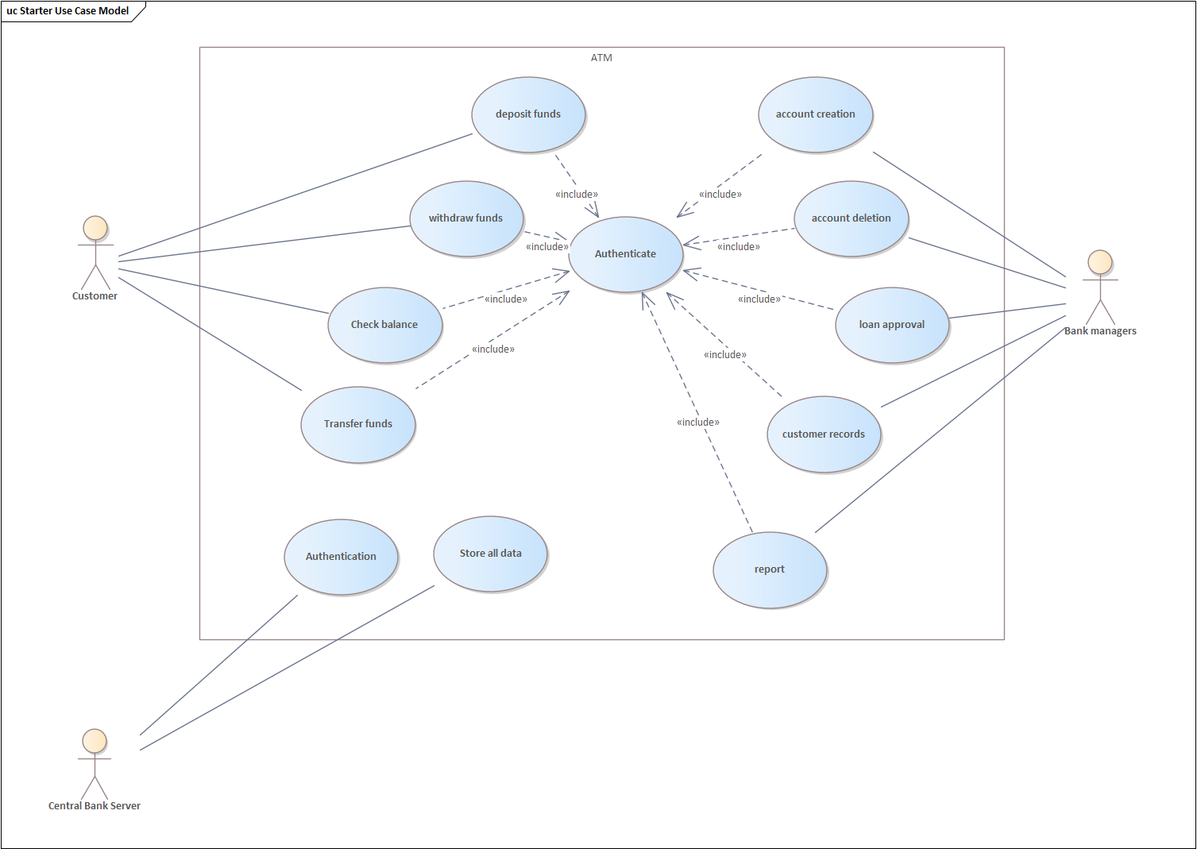

1. **Sequence Diagram**
2. Authenticate

1. Deposit Money

1. Class Diagram

1. Collaboration Diagram

1. Statechart Diagram

1. Activity Diagram

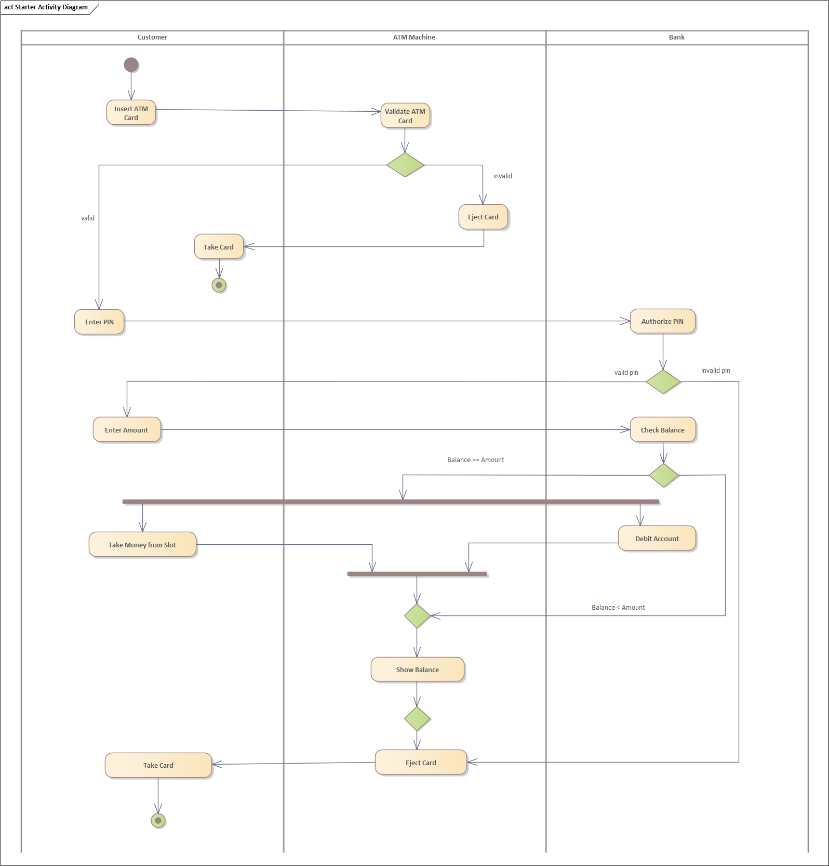

1. **Component Diagram**

1. Component Diagram

